(a)Navigate and List :

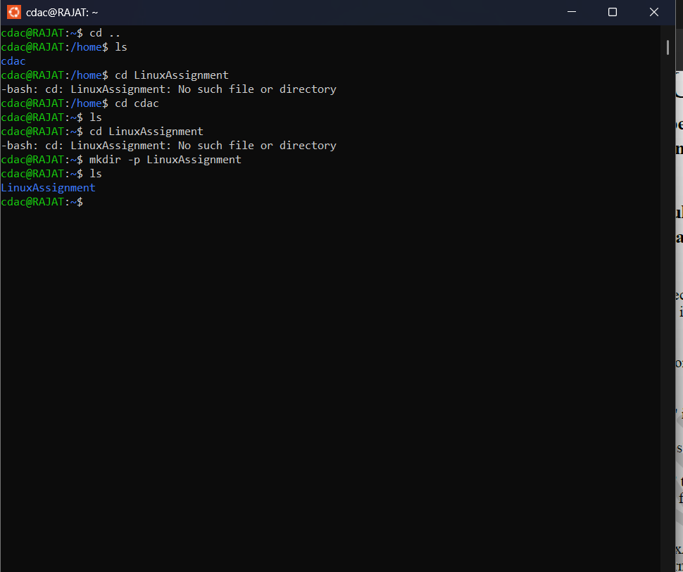

(b) File Management :

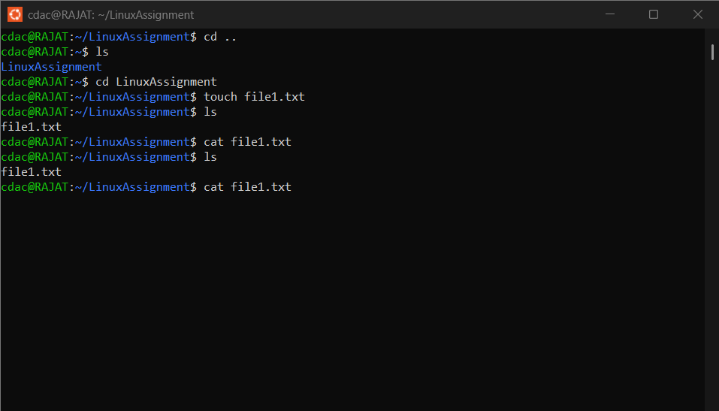

(c) Directory Management :

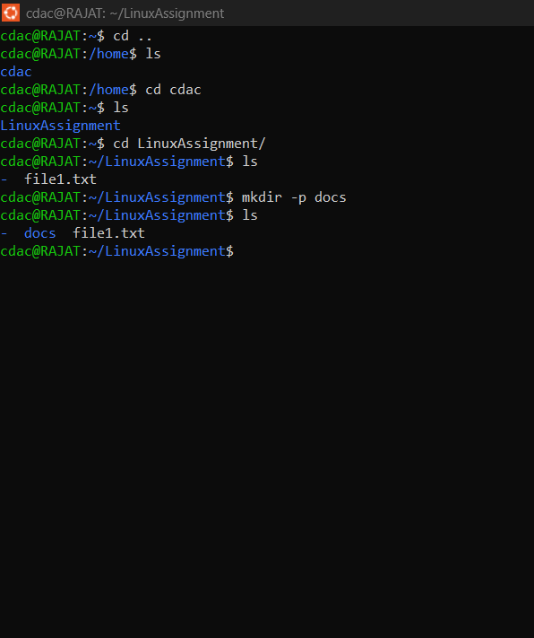

(d) Copy and Movie Files :

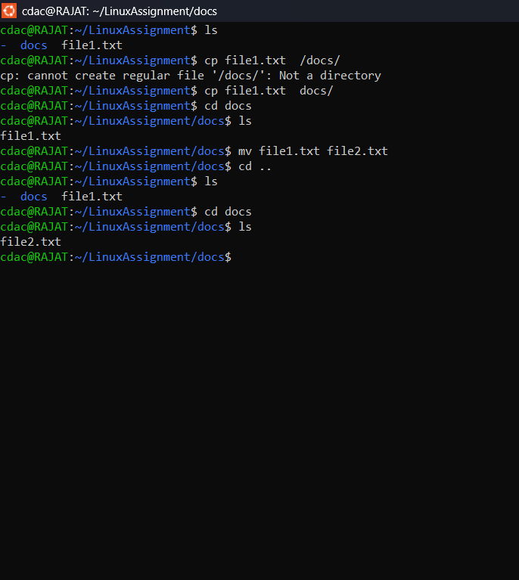

(h) System date and time :

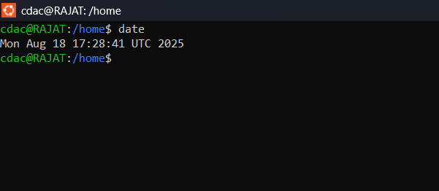

--------------------------------------------------------------------------------------------------------------------------------------

(i)Networking (a): Ipaddress of the system :

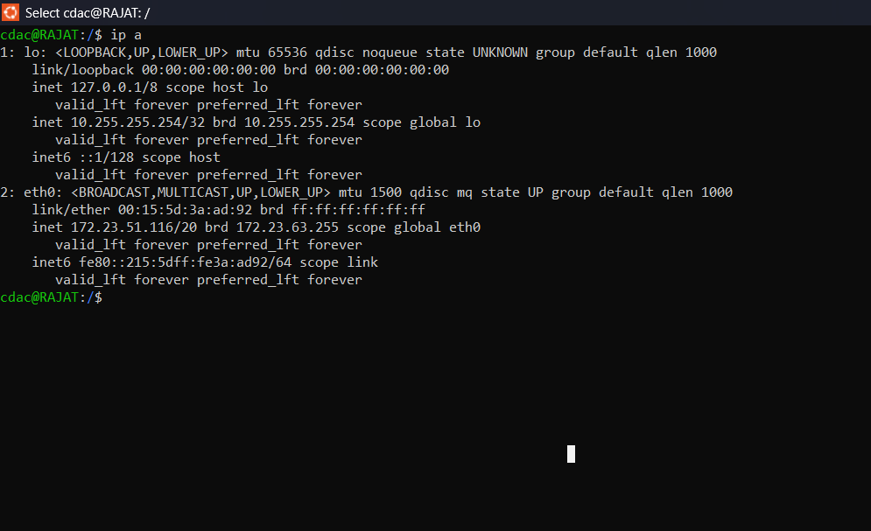

(i)Networking (b): ping remote server :